Certain websites are repetitive in the list
Reliable websites for competitions:

- https://www.ibef.org/
- https://www.mordorintelligence.com/
- https://www.greatassignmenthelp.com/blog/sustainability-research-topics/
- https://www.entrepreneurindia.co/
- https://www.niir.org/
- https://pipecandy.com/
-https://www.maximizemarketresearch.com/
-https://blog.contactpigeon.com/customer-engagement-statistics/
- NITI AAYOG
- - https://www.technospak.com/
https://www2.deloitte.com/us/en/insights/strategy.html?icid=disubnav_strategy
- https://www.weforum.org/
- https://www.indiastat.com/
- https://www.bcg.com/
- https://instagram.com/eco.medy?igshid=MmU2YjMzNjRlOQ==
- https://redseer.com/
- https://www.kearney.com/
- https://www.techsciresearch.com/
- https://www.marketresearch.com/
- https://www.investindia.gov.in/
- https://niryat.gov.in/#?start_date=202304&end_date=202307&sort_table=export_achieved-sort-desc (To know analysis of Import and export from India to the world about various kind of sectors)
Reliable websites for competitions:

- https://www.ibef.org/
- https://www.technopak.com/
- https://www.mordorintelligence.com/
- https://www.greatassignmenthelp.com/blog/sustainability-research-topics/
- https://www.entrepreneurindia.co/
- https://www.niir.org/
- https://pipecandy.com/
-https://www.maximizemarketresearch.com/
-https://blog.contactpigeon.com/customer-engagement-statistics/
- NITI AAYOG
- https://www2.deloitte.com/us/en/insights/strategy.html?icid=disubnav_strategy
- https://www.weforum.org/
- https://www.indiastat.com/
- https://www.bcg.com/
- https://instagram.com/eco.medy?igshid=MmU2YjMzNjRlOQ==
- https://redseer.com/
- https://www.kearney.com/
- https://www.techsciresearch.com/
- https://www.marketresearch.com/
- https://www.investindia.gov.in/
- https://niryat.gov.in/#?start_date=202304&end_date=202307&sort_table=export_achieved-sort-desc (To know analysis of Import and export from India to the world about various kind of sectors)
- https://www.grandviewresearch.com/

- Open Government Data (OGD) Platform India – data.gov.in – is a platform for supporting Open Data initiative of Government of India.

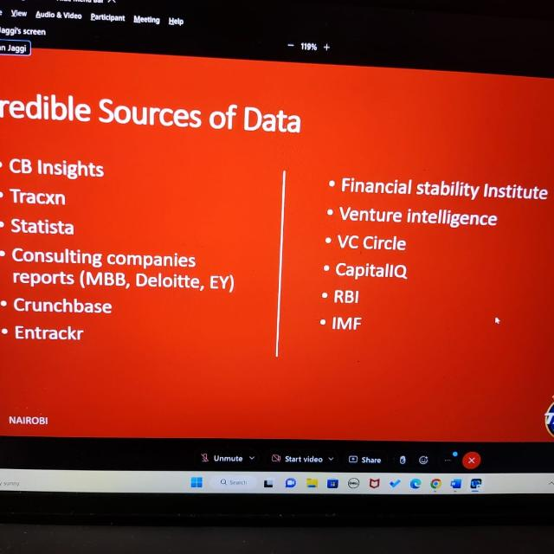

- Apart from these websites we researched by visiting websites and annual reports of prominent companies/competitors in that industry (The problem statement is about some industry/company)
- For primary research – Talk to consumers, retailers, distributors, and financial analysts from the industry (connect through LinkedIn)
- All these apart from brainstorming among team members.

